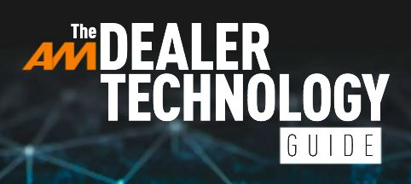
AM will publish its 2025 Dealer Technology Guide at the end of June.
If you have developed an innovative hardware solution or digital innovation for the UK’s motor retail sector and would like to be included in its editorial pages, please complete this form with the information we’re requesting for inclusion and return it by Friday, June 6th.

What is the name of your product / technology? | Click or tap here to enter text.
What is the name of your company? | Click or tap here to enter text.
Select ONE of the following Tech Guide sections in which the above-named product / technology should be included. | ☐Aftersales Support Systems and Equipment  ☐Consumer Finance and Compliance  ☐Customer Relationship Management  ☐Dealer Management Systems and Accounts  ☐Electronic Document Management Systems  ☐EV Chargers and Infrastructure  ☐IT, Connectivity and Communications Systems  ☐Lead Management Solutions  ☐Online Vehicle Retailing Solutions  ☐Part Exchange Appraisal and Management  ☐Sales Support Solutions  ☐Security and Cyber Security  ☐Stock Acquisition and Management  ☐Other Dealer Technology not specified above
FOR PUBLICATION: Describe, in complete sentences, the main features or elements of the product / technology.  Then describe, in complete sentences, the main benefits of the product/technology for motor retailers. (TOTAL 160 WORDS MAXIMUM) | Click or tap here to enter text.
FOR PUBLICATION: Provide a webpage address where dealers can find out more about the specific technology. | Click or tap here to enter text.
OPTIONAL Provide colour image(s) for the product, or provide a dropbox link to image |  | Click or tap here to enter text.
NOT FOR PUBLICATION Provide your name, job title and contact email/number for our editorial records. | Click or tap here to enter text.

Please email the completed form to matt.deprez@bauermedia.co.uk while copying in tim.rose@bauermedia.co.uk by 10am on Friday, June 6th to ensure it is processed in time for production of the Dealer Technology Guide.

